CHAPTER 1
INTRODUCTION

  - AIM OF THE PROJECT:
The aim of the “Surveillance Robot” is to help a person to surveillance the required area.

1.2 INTRODUCTION TO THE PROJECT:
Surveillance Robot helps the person controlling surveillance the required area. This is done using various software and hardware components necessary and successfully interfacing all the above.

1.3 LITERATURE SURVEY:
In times of natural disasters like earthquakes or tsunamis, the rescue teams always face a challenging job to find the people who are stuck under some debris or in some inaccessible place. In such scenarios, robots can be employed to find the location and condition of the people under any circumstances and to inform the rescue team. It can also be used in military applications for the surveillance of enemy territory.

1.4 ORGANISATION OF THE PROJECT:
The project can be divided into two parts. One is the mobile robot part and the other is the stationary part containing the Laptop.
The mobile part contains the robot with a wireless camera mounted on it. It runs on four wheels supported by DC motors. All the circuitry is inside the bot and is not visible on the outside. The stationary part contains the Laptop which is used to receive the live feed from the mobile bot and read it on the laptop.

CHAPTER 2
ARCHITECTURE

2.1 COMPONENTS USED
2.1.1 Hardware Components:
- Node MCU
- Raspberry PI
- L298N
- DC motors
- Li-acid Battery
- Raspberry Pi camera

2.1.2 Software Components:
- Arduino IDE
2 VNC VIEWER

2.2 COMPONENTS DESCRIPTION
2.2.1 Hardware
2.2.1(a) NodeMcu:
The NodeMcu is an open-source firmware and development kit that helps you to Prototype your IOT product within a few Lua script lines.

Features:
• Open-source
• Interactive
• Programmable
• Low cost
• Simple
• Smart
• WI-FI enabled

Arduino-like hardware IO:
Advanced API for hardware IO, which can dramatically reduce the redundant work for configuring and manipulating hardware. Code like arduino, but interactively in Lua script.

Nodejs style network API:
Event-driven API for network applicaitons, which faciliates developers writing code running on a 5mm*5mm sized MCU in Nodejs style. Greatly speed up your IOT application developing process.

Specification: The Development Kit based on ESP8266, integates GPIO, PWM, IIC, 1-Wire and ADC all in one board. Power your developement in the fastest way combinating with NodeMCU Firmware!
• USB-TTL included, plug&play
• 10 GPIO, every GPIO can be PWM, I2C, 1-wire
• FCC CERTIFIED WI-FI module（Coming soon）
• PCB antenna

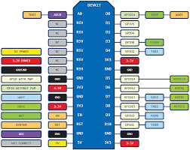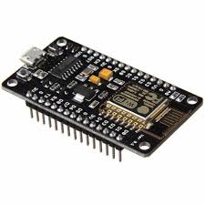

Fig 1 : Node MCU

2.2.1(b) L298N
L293D is a typical Motor driver or Motor Driver module which allows DC motor to drive on either direction. L298N consists of L293D, which is a 16-pin IC which can control a set of two DC motors simultaneously in any direction. It means that you can control two DC motor with a single L298N module.
.
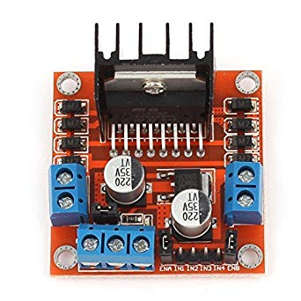
Fig 2 : L298N module

2.2.1(c) DC motors

A DC motor is any of a class of rotary electrical machines that converts direct current electrical energy into mechanical energy. The most common types rely on the forces produced by magnetic fields. Nearly all types of DC motors have some internal mechanism, either electromechanical or electronic, to periodically change the direction of current flow in part of the motor.

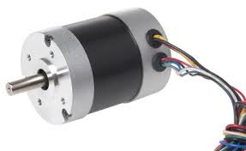
Fig 3 : DC MOTOR

2.2.1(d) Raspberry Pi
The Raspberry Pi is a series of small single-board computers developed in the United Kingdom by the Raspberry Pi Foundation to promote teaching of basic computer science in schools and in developing countries. The original model became far more popular than anticipated, selling outside its target market for uses such as robotics. It does not include peripherals (such as keyboards and mice) and cases. However, some accessories have been included in several official and unofficial bundles.
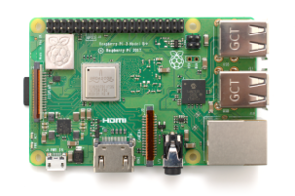
Fig 4. Raspberry Pi

2.2.1(e) LiPo battery

An electric battery is a device consisting of one or more electrochemical cells with external connections provided to power electrical devices such as flashlights, smartphones, and electric cars. When a battery is supplying electric power, its positive terminal is the cathode and its negative terminal is the anode. The terminal marked negative is the source of electrons that when connected to an external circuit will flow and deliver energy to an external device. When a battery is connected to an external circuit, electrolytes are able to move as ions within, allowing the chemical reactions to be completed at the separate terminals and so deliver energy to the external circuit. It is the movement of those ions within the battery which allows current to flow out of the battery to perform work. Historically the term "battery" specifically referred to a device composed of multiple cells, however the usage has evolved additionally to include devices composed of a single cell.


Fig 5 : Battery

2.2.1(e) Raspberry Pi Camera

The Raspberry Pi camera is camera module which can be interfaced by using Raspberry Pi. It is a small, powerful camera which can be used for many applications. The live feed which can sent to the laptop over Wi-Fi.

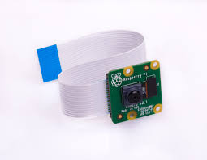

Fig 6 : Camera module

2.2.2(a) Arduino IDE
The Arduino Integrated Development Environment - or Arduino Software (IDE) - contains a text editor for writing code, a message area, a text console, a toolbar with buttons for common functions and a series of menus. It connects to the Arduino and Genuino hardware to upload programs and communicate with them.
Programs written using Arduino Software (IDE) are called sketches. These sketches are written in the text editor and are saved with the file extension .ino. The editor has features for cutting/pasting and for searching/replacing text. The message area gives feedback while saving and exporting and also displays errors. The console displays text output by the Arduino Software (IDE), including complete error messages and other information. The bottom righthand corner of the window displays the configured board and serial port. The toolbar buttons allow you to verify and upload programs, create, open, and save sketches, and open the serial monitor.

CHAPTER 3
IMPLEMENTATION AND WORKING

    - Block diagram

APP
NODE MCU
ROBOT

RASPBERRY PI

LAPTOP

3.2 Bot code

#include<ESP8266WiFi.h>

String i;

WiFiServer server(80); //creates a WiFiServer with the given identifier and port number

void setup() { // put your setup code here, to run once:
i="";
Serial.begin(9600);
pinMode(16,OUTPUT);
pinMode(15,OUTPUT);
pinMode(4,OUTPUT);
pinMode(0,OUTPUT);
//pinMode(2,OUTPUT);
//pinMode(14,OUTPUT);
//pinMode(12,OUTPUT);
//pinMode(13,OUTPUT);
//pinMode(15,OUTPUT);

WiFi.disconnect(); //to disconnect the nodemcu from the previous WiFi connection
delay(2000);
Serial.println("Connecting to Wifi");
WiFi.begin("Srilaxminet","narayana234"); //to specify the username and password of the network to be connected
while((!(WiFi.status()==WL_CONNECTED)))
{
delay(300);
Serial.print("...");
}
Serial.println("I am connected");
Serial.println("My local IP is : ");
Serial.print((WiFi.localIP())); //returns IP address of the local network
server.begin(); //to initiate the WiFiserver created previously
}

void loop()
{
WiFiClient client=server.available(); //to create a WiFi client
if(!(client))
{
return;
}
while(!client.available())
{
delay(1);
}
i=(client.readStringUntil('\r'));
i.remove(0,5);
i.remove(i.length()-9,9);
if(i=="forward")
{
digitalWrite(16,HIGH);
digitalWrite(5,LOW);
digitalWrite(4,HIGH);
digitalWrite(0,LOW);
//Serial.println("forward");
Serial.println("\n forward");
}
if(i=="reverse")
{
digitalWrite(5,HIGH);
digitalWrite(16,LOW);
digitalWrite(0,HIGH);
digitalWrite(4,LOW);
//Serial.println("forward");
Serial.println("\n reverse");
}
if(i=="stop")
{
digitalWrite(16,LOW);
digitalWrite(5,LOW);
digitalWrite(4,LOW);
digitalWrite(0,LOW);
//Serial.println("forward");
Serial.println("\n stop");
}
if(i=="left")
{
digitalWrite(16,LOW);
digitalWrite(5,LOW);
Serial.println("left");
}
if(i=="right")
{
digitalWrite(16,HIGH);
digitalWrite(5,LOW);
digitalWrite(4,LOW);
digitalWrite(0,LOW);
delay(2000);
//Serial.println("forward");
Serial.println("right");
}
if(i=="left")
{
digitalWrite(16,LOW);
digitalWrite(5,LOW);
digitalWrite(4,HIGH);
digitalWrite(0,LOW);
delay(2000);
//Serial.println("forward");
Serial.println("left");
}
}
\

  - Working explanation:

The robot can be controlled using the android application when connected over the same Wi-Fi. The camera streams the live feed into the laptop over Wi-Fi. This will help the controller of the robot to surveillance the area by viewing the live feed in the laptop.

CHAPTER 4
EXPERIMENTAL RESULTS AND CONCLUSIONS

Results: The robot can now successfully be controlled over Wi-Fi and the live feed will be shown in the laptop.

Future Enhancements: The robot will be made autonomous which will surveillance on its own.

Conclusion: The robot can be used can be used in scenarios where we need to help the trapped victims and has many other applications.

